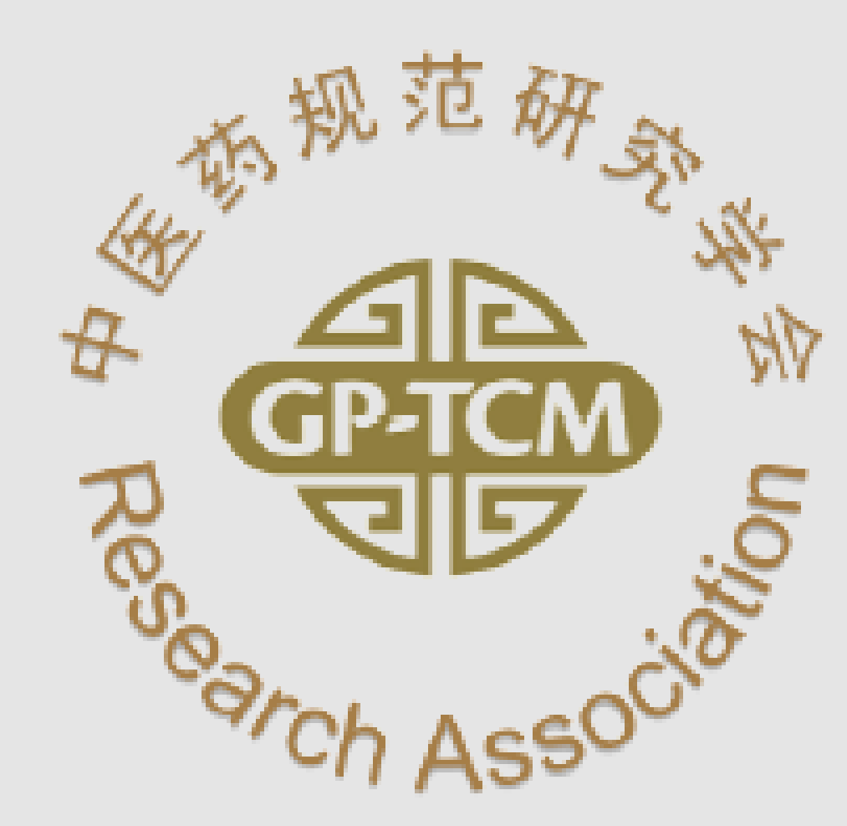
The 14th Annual Meeting of The Good Practice in Traditional Chinese Medicine Research Association (GP-TCM RA)
Date: 7-9 July 2026
Venue: Nanyang Technological University, Singapore
Abstract submission form

Guidelines for Submission of Abstracts
- Abstract submission for poster presentations is now open to all researchers in the field of traditional Chinese medicine or herbal medicines
- All abstracts must be submitted in doc- or docx-format to: gptcmra.sg@gmail.com not later than 7th May 2026. Please note that abstracts sent by pdf will not be accepted.
- Your abstract should be prepared according to the following instructions (abstracts that do not follow the format will not be accepted):
- Please prepare your abstract using the below abstract form.
- The abstract must be written in English and it should be brief and concise. Concerning style please refer to the below abstract template (confined to one A4 page).
- The maximum length of the main text must not exceed 300 words (excluding references, acknowledgement). The abstract can include figures, tables, references and acknowledgement. Longer abstracts will be rejected.
- Statistical evaluation is obligatory for pharmacological and clinical data. Do not use phrases like “… results will be presented…” Abstracts will undergo a strict peer review process. Abstracts without definite results will not be accepted.
- Abstracts accepted for poster presentation at the conference will be notified by end-May with details on preparation of the poster. In addition, some abstracts will be selected and invited for flash poster presentations, i.e. a 2-minute slot for you to present a verbal overview of your poster at the conference. All presented posters will be eligible for the best poster awards (except those travel awardees).
- Based on the merit of the submitted abstracts, students or postdoc (within 3 years of getting their PhD degrees) are eligible for the travel awards.

Presenting Author (All presenters are required to register for the conference separately)
Title: | ☐ Prof ☐ Dr ☐ Mr ☐ Mrs ☐ Ms ☐ Others: ___________________
First name: |  | Last name:
Position:
Department:
Institution / Company:
E-mail:
Only for students or postdoc (must be within 3 years of getting their PhD degrees, proof will be required later) :

I would like to apply for the travel award ☐ yes (please tick)

Corresponding Author
Title: | ☐ Prof ☐ Dr ☐ Mr ☐ Mrs ☐ Ms ☐Others: __________________
First name: |  | Last name:
Position:
Department:
Institution / Company:
Mailing address:
Telephone: (country/area code)
E-mail:

Abstract Form
Abstract title (Arial/ 12 pt/ bold/ single line spacing/ maximum 2 lines)
Title continued (if necessary)
Author Aª, Author B^{b}, Author Cª, etc. (Arial/ Italics/ 11 pt/ Underline the presenting author, asterisk* the corresponding author)
ª Institution corresponding to author a, address, postal code, country; ^{b} Institution corresponding to
author b, address, postal code, country (Arial/ 10 pt/ single line spacing)
[One empty line: Arial 10 pt]
Correspondence: name and e-mail address (Arial/ 10 pt/ single line spacing)
[One empty line: Arial 10 pt]
Main text (Arial 11 pt/normal/ single line spacing/ left and right justification, not exceeding 300 words):
Introduction (includes the aim of the study):…

Materials and Methods:…

Results:…

Conclusions:…

References: (if any): 1. Wong, XX, et al. Journal name, 2023. Vol: page; 2. Chan et al. Journal name, 2023. Vol: page.

Text of the abstract can include figures and tables, but the entire abstract needs to be within this A4 page

Acknowledgements: (Arial / Italics/ 10 pt)

I agree that this abstract will be included in the conference abstract booklet ☐ yes ☐ no (please tick)
I agree that this abstract will be published in our official journal World Journal of Traditional Chinese Medicine ☐ yes ☐ no (please tick)

To be sent to: gptcmra.sg@gmail.com

